Current Status of Hexapod Research

At Southern Illinois University Edwardsville

Andrew Kutta

Faculty Member: Dr. Gary Mayer

As Partial Fulfillment of CS 495 - Independent Study

* Background

The goal of the project is to allow a robot to dynamically and autonomously change its own stride so that it may navigate terrain in a more efficient manner. "Efficiency" is defined for this project in terms of power consumption with respect to motion. The thought behind this is that the leg lengths can be changed for longer strides on level terrain, and the lengths may all be homogeneous. On sloped terrain, the legs fore and aft may be set such that the center of gravity of the robot may be adjusted to help avoid slipping and toppling. For rugged terrain, the robot can change each individual leg length to better counteract terrain irregularities such as low obstacles. The robots general design is the use of six legs with three segments per leg. Two of the segments will be capable of dynamic length change.

With such specific requirements, there is a lack of off-the-shelf parts. There are linear servos that would provide sufficient torque and speed for extending a leg segment; however, the need for twelve linear servos exceed the budget and would require fabricaion of leg segments around the design of the linear servo. As a result, the standard, high-torque rotational servos are being used. The rotational motion needs to be converted to translational motion; however, there are no appropriate devices available off the shelf that can be directly applied to our general design. Thus, a three-dimensional (3D) rapid-prototyping printer is being used to fabricate leg components.

The 3D printer being used is the uPrint SE 3D Printer. Using this printer limits the physical dimensions of printed parts to 8 in x 6 in x 6 in. The printer uses an ABSplus material, which is an industrial strength thermoplastic. This plastic has a Flexural Strength of 53 MPa and tensile strength of 37 MPa. The use of the 3D printer benefits our prototyping capabilities by allowing quick-turn feedback of designs using a relatively inexpensive method.

The printer requires a file exported in the .STL file format to be capable of properly creating tooling for the printer. The CAD program used has no limitations other than being capable of exporting as a .STL file format for the 3D printer. During the research this semester, the preferred CAD program was AutoDesk Inventor. This program has many design accelerators to enable designing certain aspects quicker and more accurately, including gears. The only issue that arises is that when exporting to .STL with the base drawing being defined in millimeters the units need to be scaled by ten. This scaling can be achieved through the printing software before sending to the printer, external from the CAD program.

* Previous Research

Previous work related to hexapod robots and movement was largely based on a theoretical standpoint. Many use Matlab to create simulations of a hexapods movement, but few have created a working robot to test these theories with. Benefits that have come from these works include creating a standardized definition of efficiency in terms of a hexapods movement. Unfortunately, even with these simulations, the leg lengths were expected to be static lengths. This prevents the robot from assuming a more efficient gait based on the terrain that is encountered. As a result, equations are laid out for performing the simplest gait; however, the practice of using it has not been put fully to the test.

A single robot was created to simulate having six legs as seen in Figure 6. This robot cannot be applied to our study despite demonstrating movement on six “legs.” The legs do not contain any joints and as such cannot be applied to a hexapod efficiency model. The gait is completely uniform and impossible to change as the legs act as wheels. The advantage over wheels that this design has is that it would be better at climbing objects with a height less than the diameter of the wheel.

* Study and Progression of Robot

Before this project, Dr. Mayer and I had no experience with the 3D printer. As a result, many iterations have been performed on the design of the leg segments. The robot was initially envisioned to have each full leg extend two feet. This was due to the printer’s limitations of having a maximum printable length of eight inches. Each leg segment needed to be capable of converting rotational motion into linear motion in an efficient manner. The method of doing this that was decided upon was by using a screw to push and pull a threaded inner leg segment and a single design of a leg segment should used for each all leg segments allowing for more efficient printing of the robot.

The initial design of the inner and outer leg segment had an overall dimension of 2” x 2” x 8”. The object needed to be scaled down by 10% to allow the printer to lay the necessary support material for the object as well. The main conclusion made after this iteration was that the screw design did work well for extending and retracting the inner arm. Issues found also included the need to scale the width and height down but keep the overall length of the segment and to increase all wall thicknesses to a minimum of 2mm. The screw was designed to fit into a seat with a key from above that secured the screw in place. The head of the screw was a hexagonal key sized to fit properly into a standard socket. On the initial printing of the objects, the tolerance of the printer was not properly accounted for. The printer that is being used has a x-y tolerance of 0.15 mm and a z tolerance of 0.2 mm. It was soon discovered, that despite working reasonably well, the tolerance between the screw and the inner leg segment needed to be 0.3 mm to allow the screw to spin freely.

After scaling the segment down, the overall dimensions were changed to 27mm x 27mm x 200mm. This enabled the length of the segment easily print with enough support material to allow proper printing of the pieces. The overall design was not changed, as everything appeared to function properly. The issue that began appearing as the objects became smaller is that tolerances of the printer needed to be properly accounted for. In a test to determine how well an object could be printed within another, these tolerances make a huge difference. By using the previously stated 0.3mm tolerance, an object can easily be printed within another object. This iteration also yielded information that the printer is not as exact as we would prefer. The tracks that the inner leg segment was designed to slide along did not properly conform to all configurations that the leg segment could be inserted into the outer leg segment. Even with a good fit, the rails were found to need changes when testing the ability to handle a torsional load on the inner leg segment. As a result the rails were modified and two rails along the exterior of the inner leg segment were added. This made it impossible for the inner arm to rotate and still allowed enough freedom to easily extend and retract.

After this iteration, the rate at which the leg segment could be extended was tested. With the current pitch of the screw, the leg segment was self-locking, which prevented needing to constantly apply power to the motor to maintain the leg segments length. However, the rate at which the segment could be fully extended from the retracted position was not within the two-second expectation. The ability for the screw to be self-locking was greatly desired, as it would improve our efficiency by limiting power consumption. As a result, the pitch of the threads was not going to be changed. To compensate for this, the screw needed to move two times faster than it currently was. In addition, the amount of torque present in the system was far superior to what was anticipated. As a result, a gearbox was designed to fit on the end of the motor and fit directly onto the screw. This would in turn gear up the motor so that the rate at which the screw spun was at a ratio of 2:1 when compared to the rate that the motor spun at.

The gearbox was designed so that it could be interchanged with another by providing a larger footprint than necessary to house the gears. This enables the gear ratio to increase or decrease with no need to change the outer form of the gearbox. The gearbox input is the motors shaft and the output is a socket that fits onto the screw. The main problems found after the first two iterations of the gearbox were that the support for securing the intermediary gear were not strong enough, the lid had a tendency to be pushed up causing the gears to sleep, and the plastic was not strong enough to handle the high torque produced by the motor. Combining the intermediary gear and the gearbox top together as a single piece and increasing the size of the supports corrected the issue with weak supports and the gears slipping. Four pins were added to secure the lid and intermediary gear to the box. To reduce the inertia within each of the gears, the diameters of all the shafts were increased and, where possible, made hollow. The axel that the intermediary gear spun around was made hollow to reduce weight and material costs of printing. Since the input shaft was not strong enough to accept the motor shaft directly, a metal adapter was used. This adapter attached to the motor shaft and resulted in a hexagonal shape for use with the input shaft. This prevents the possibility of stripping as the amount of material in contact with a flat surface is greatly increased.

A motor housing has been designed that contains the motor and gearbox which then attaches to the outer arm. The design has not been prototyped yet as the initial design of the gearbox had changed to accommodate the improvements. When finished with this semester, I plan to have the housing capable of being printed and accommodate the new gearbox design. The purpose of the motor housing is to secure the motor to the screw and outer arm. The motor itself will be a large portion of the overall leg segments weight. As a result the main pivot point on the leg should be as close to the center of gravity as possible to allow efficient movement of each segment. A servo used to change the angle of a segment relative to the driving leg segment will attach to a secondary pivot that does not currently have a fixed location. A desired location should be determined through experimentation of using a full leg with three leg segments properly attached to each other.

* Summary

The current status of the robot once the Fall semester of 2011 is completed is that there is a good basis of how a single leg segment will be printed. The motor housing will be updated to accommodate the new gearbox footprint and additional length from the adaptor. At the other end, where the inner leg protrudes from the outer leg, another housing has yet to be designed. This housing will contain a high-torque servo that will bend the joint between two leg segments. It will also attach to the main pivot point being built into the motor housing. Once this has been designed and printed, the leg design should be complete. The motor housing has not been tested. As such modifications to it may need to be made. Reference figures 1 through 5 to view what the current design of the leg segment is.

* References

1. S. S. Roy & D. K. Pratihar, *Study on Energy Consumption in Turning Motion of Hexapod Walking Robots.* Proceedings of the World Congress on Engineering 2011 Vol III
2. S. S. Roy & D. K. Pratihar, *Dynamic Modeling and Energy Consumption Analysis of Crab Walking of a Six-legged Robot,* Department of Mechanical Engineering, National Institute of Technology, Durgapur, India
3. M. F. Silvia, J. A. Tenreiro Machado, A. M. Lopes, *Energy Analysis of Multi-Legged Locomotion Systems*. Instituite of Engineering of Porto, Portugal
4. R. T. Schroer, M. T. Boggess, R. D. Quinn, and R. E. Ritzmann. *Comparing Cockroach and Whegs Robot Body Motions.* Case Western Reserve University, Cleveland, OH.

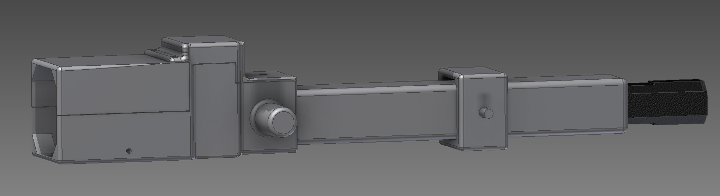

Figure 1. Current Iteration of Leg Segment

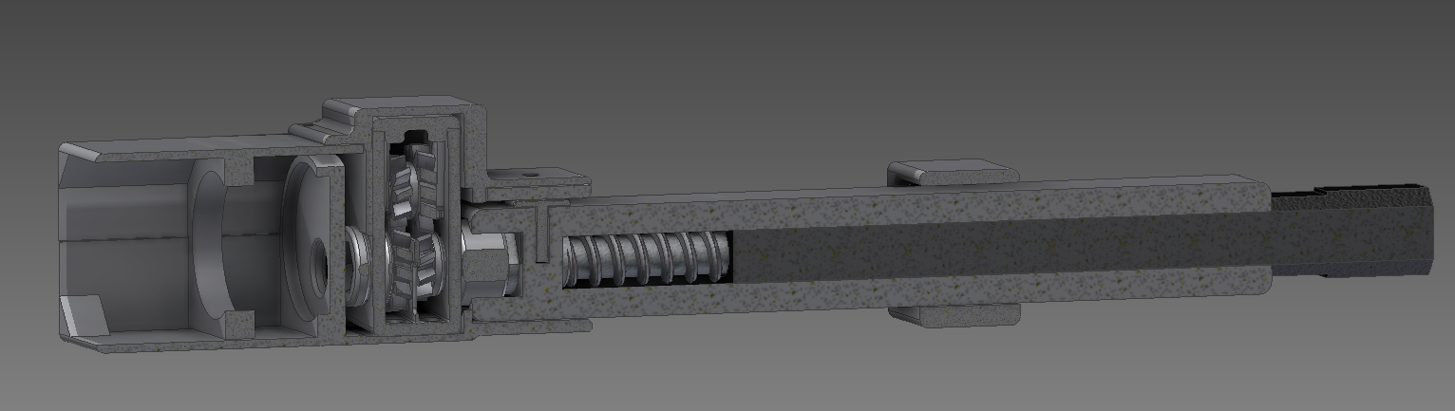

Figure 2. Current Iteration of Leg Segment with Cutaway

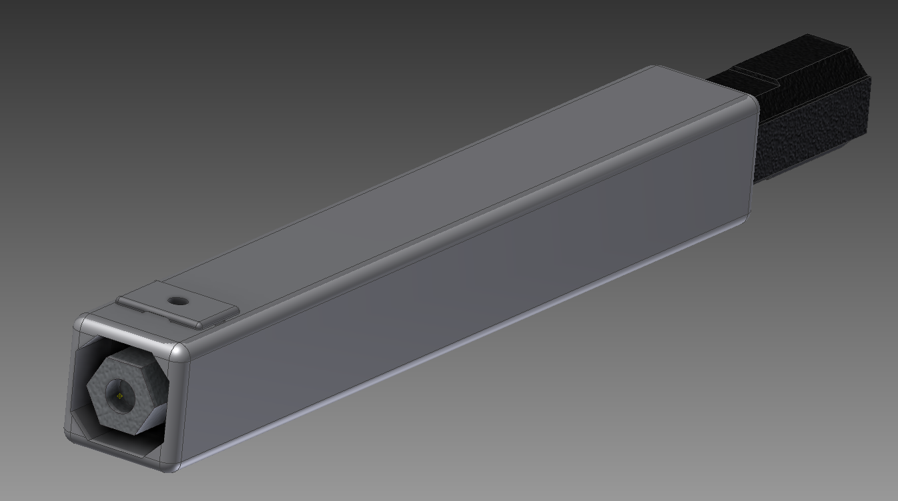

Figure 3. Perspective view of leg segment. Motor Housing not visible

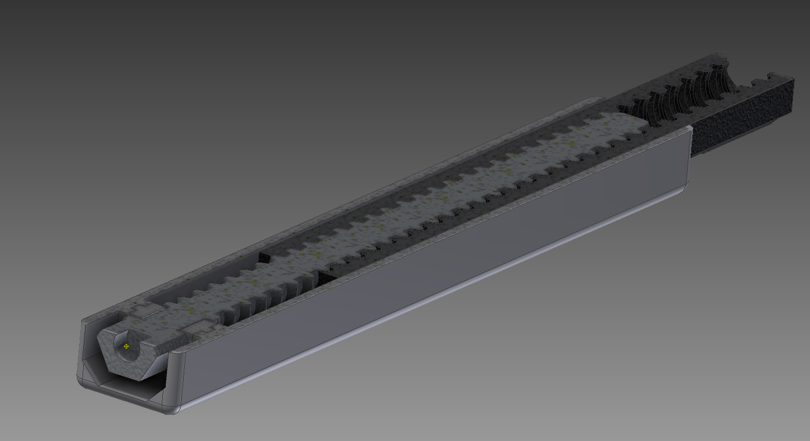

Figure 4. Cut-away from top of leg segment

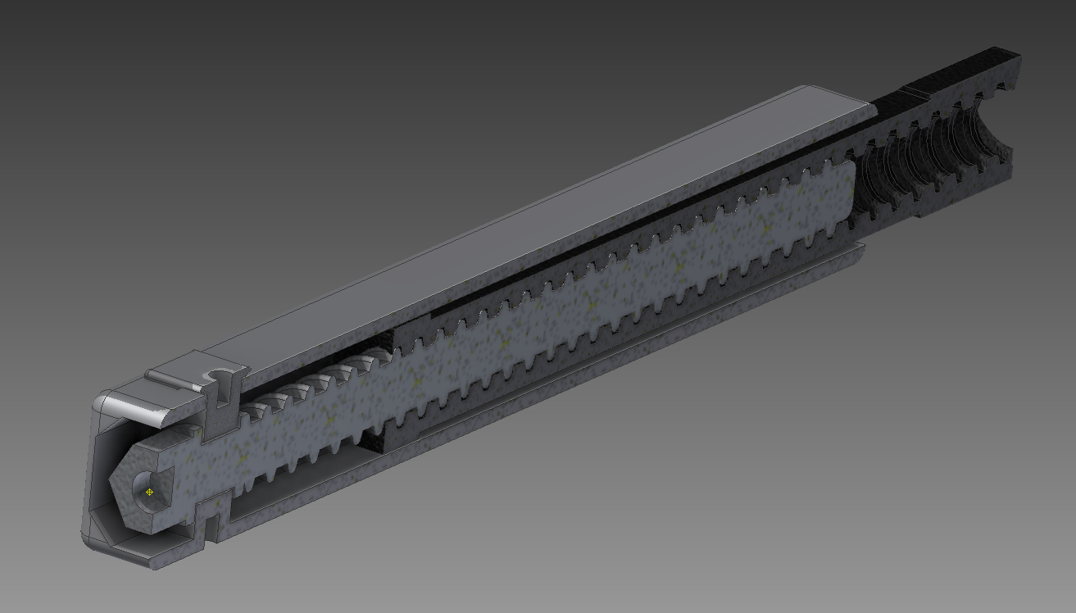

Figure 5. Cut-away from side of leg segment



Figure 6. Previous Robot To Demonstrate Hexapod Movement